I have created user accounts shipuser1 (Management level officer) and shipuser2 (Operational level officer) for testing. Password marad1234
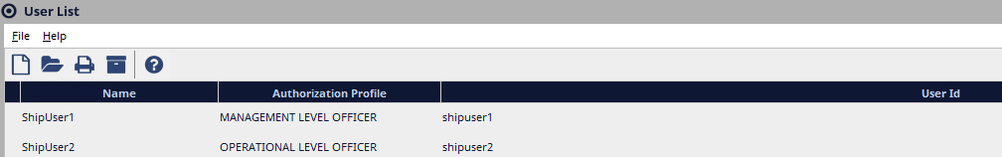

Accessing eLogs: this can be done in 2 ways:
- Open the UAT RD Web page : https://marhsawas908.ad.dot.gov/RDWeb/Pages/en-US/Default.aspx The other option to access eLogs is by directly opening the eLogs URL from a browser. The URLs are different for each site since the host’s name is part of the URL. For testing access eLogs by opening the URL: http://marhsawas908:7071/#/login from a browser.( eLogs works better if Chrome browser is used). Once at the login page, use your NSE Credentials to log in
- click on the NS-E log remote app to launch the application..
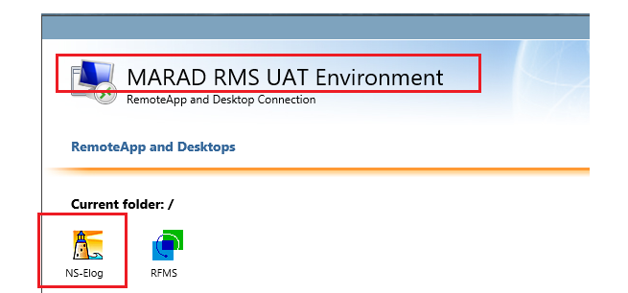
- Login to the NSE instance using your NS Account credentials.
- Click on the eLogs Module to open the module.
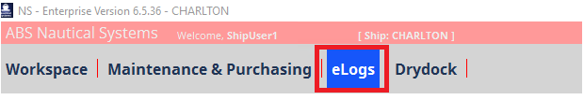
- That will open the eLogs module on MS Edge browser. eLogs is a web-based module and it will be accessed from a browser only.

.

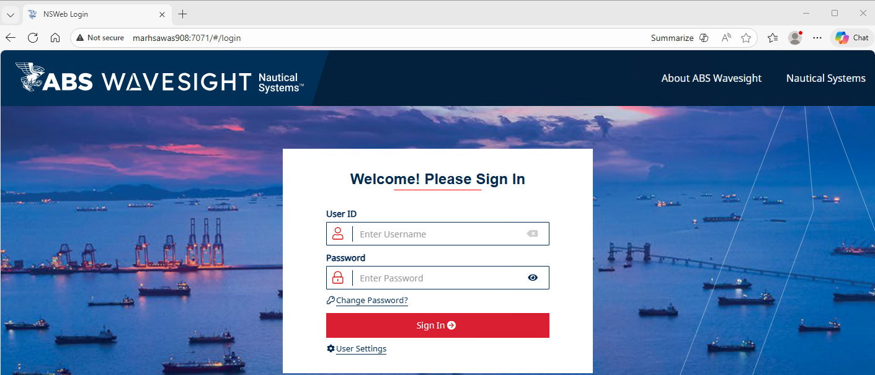

After inital login, the user selects change/Create PIN and create signature as well. Elogs has redundant security since your identity will be tied to each transaction. Therefore a PIN and Signature will are required. After each official transaction, you’ll enter your PIN and your Signature. If a signature is not saved , the user will need to create the signature each time submitting an update. We are using test account test user 1 or test user 2 and password marad1234 capturing the process creating/resetting PIN and Signature.

- After login to eLogs click on Account settings located at the top-right of the page
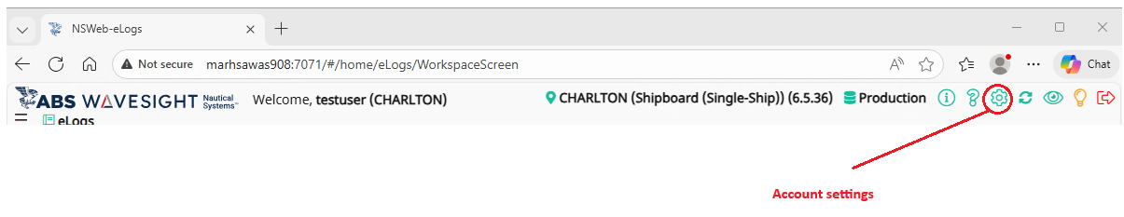
- On the user account settings page, click the Reset Pin/Password button and update your user PIN and Signature.?
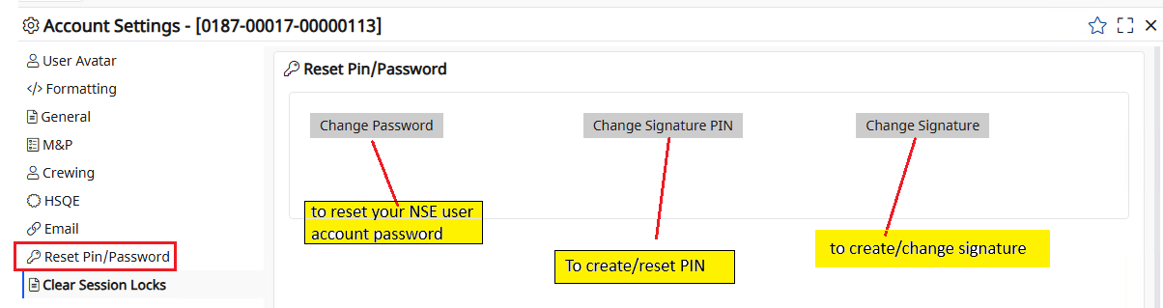

- If the user has an existing PIN (this applies to recently created NSE accounts), the system will prompt the users to enter the current Signature PIN, New Signature PIN, and Confirm Signature PIN . If the user does not have an existing PIN (this applies for older NSE accounts), the system will prompt the users to enter the New Signature PIN, and Confirm Signature PIN. Type the new PIN, Confirm the new PIN, and Save to apply the change.

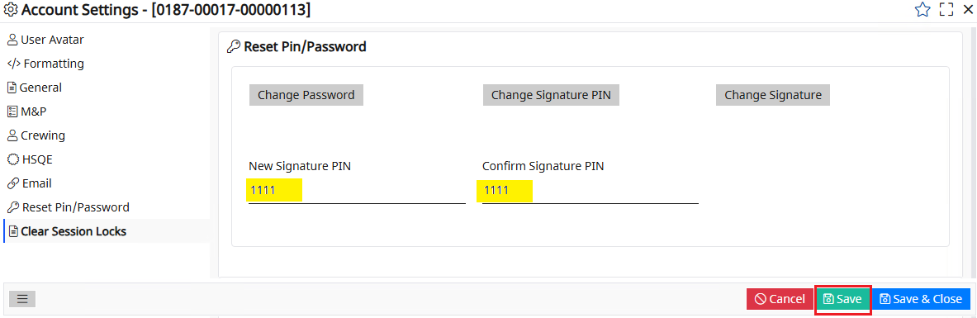
- Log out of eLogs to apply the PIN update.
- After login to eLogs, go to Accounts Settings select Reset Pin/Password Change Signature to create your signature. At this point the system will prompt the user to enter the PIN number. Enter the PIN created and click ok.
- A box will open for the user to upload or sign a signature. Click the Upload option to use an existing signature that is saved locally on your computer. Use the mouse to create your signature and click save to apply the update. The clear option is to delete an existing signature.
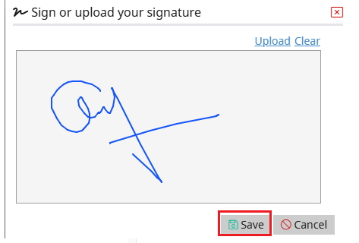

- Click on Save & Close to close Account Settings.
- Saving the Signature is important, or the user will need to sign the signature each time submitting a record update. Below is an example, when the user clicks on Sign the signature window with an existing signature. Enter the PIN and click OK to complete submitting the record update.

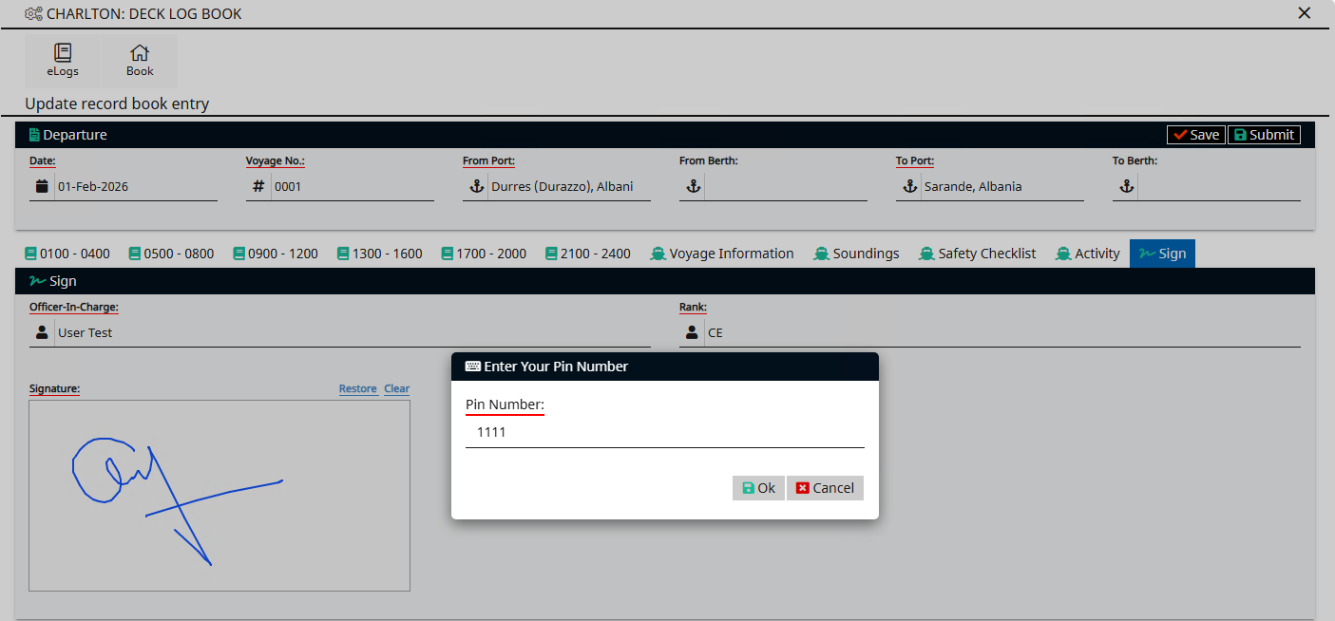

- E-log dashboard MARPOL BOOKS:
From the dashboard page please select the OIL RECORD BOOK PART1
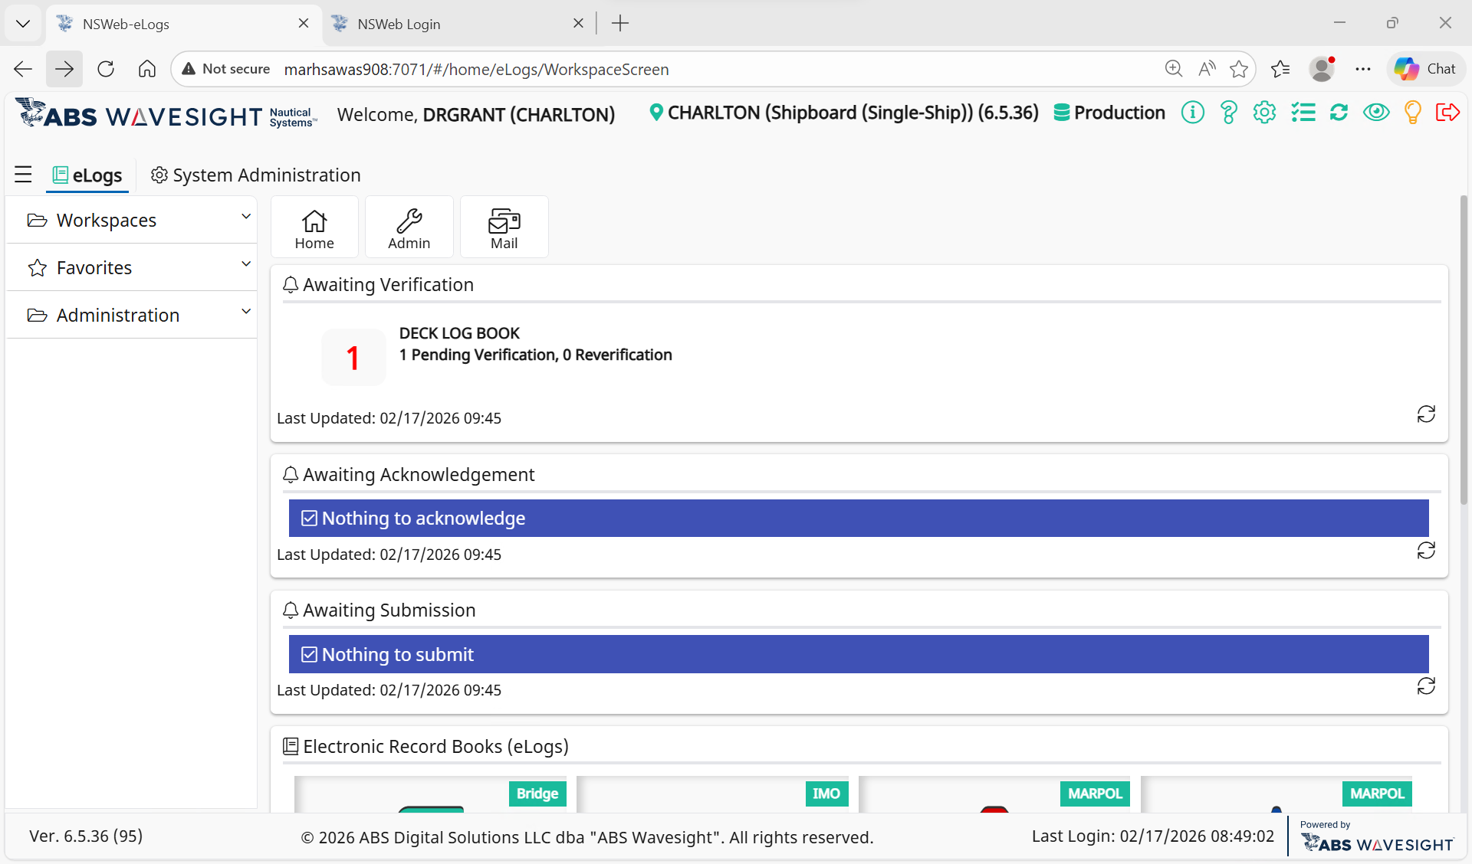

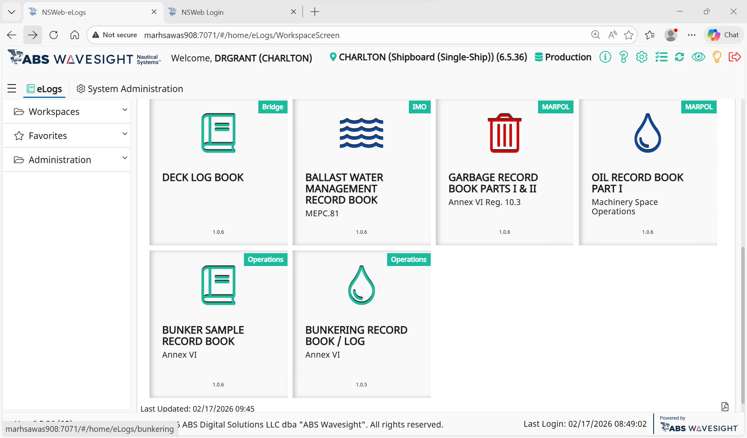

- This is the oil record book dashboard. The icons are active, you click on them to make log entries as needed
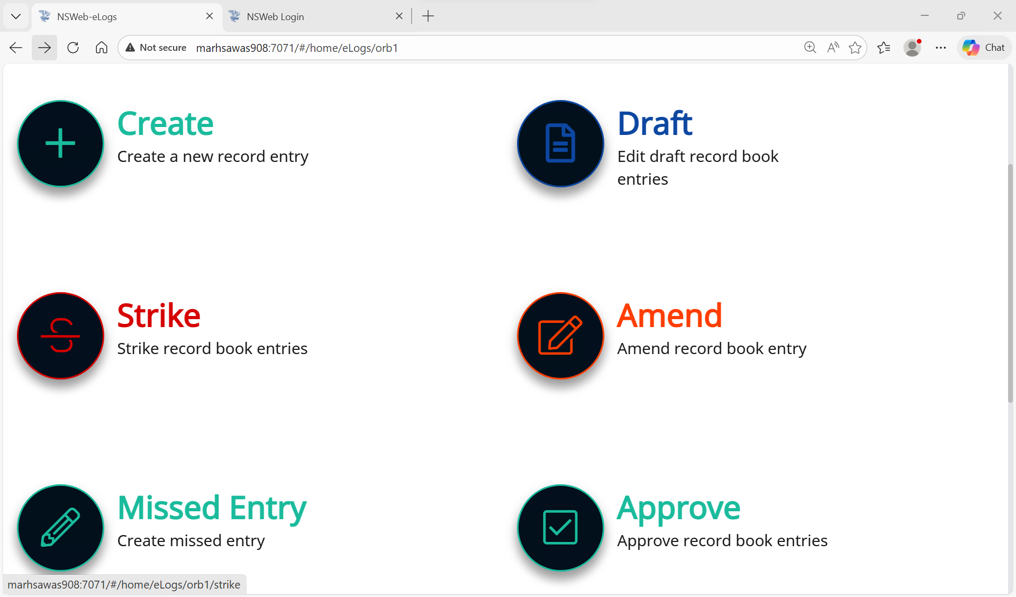
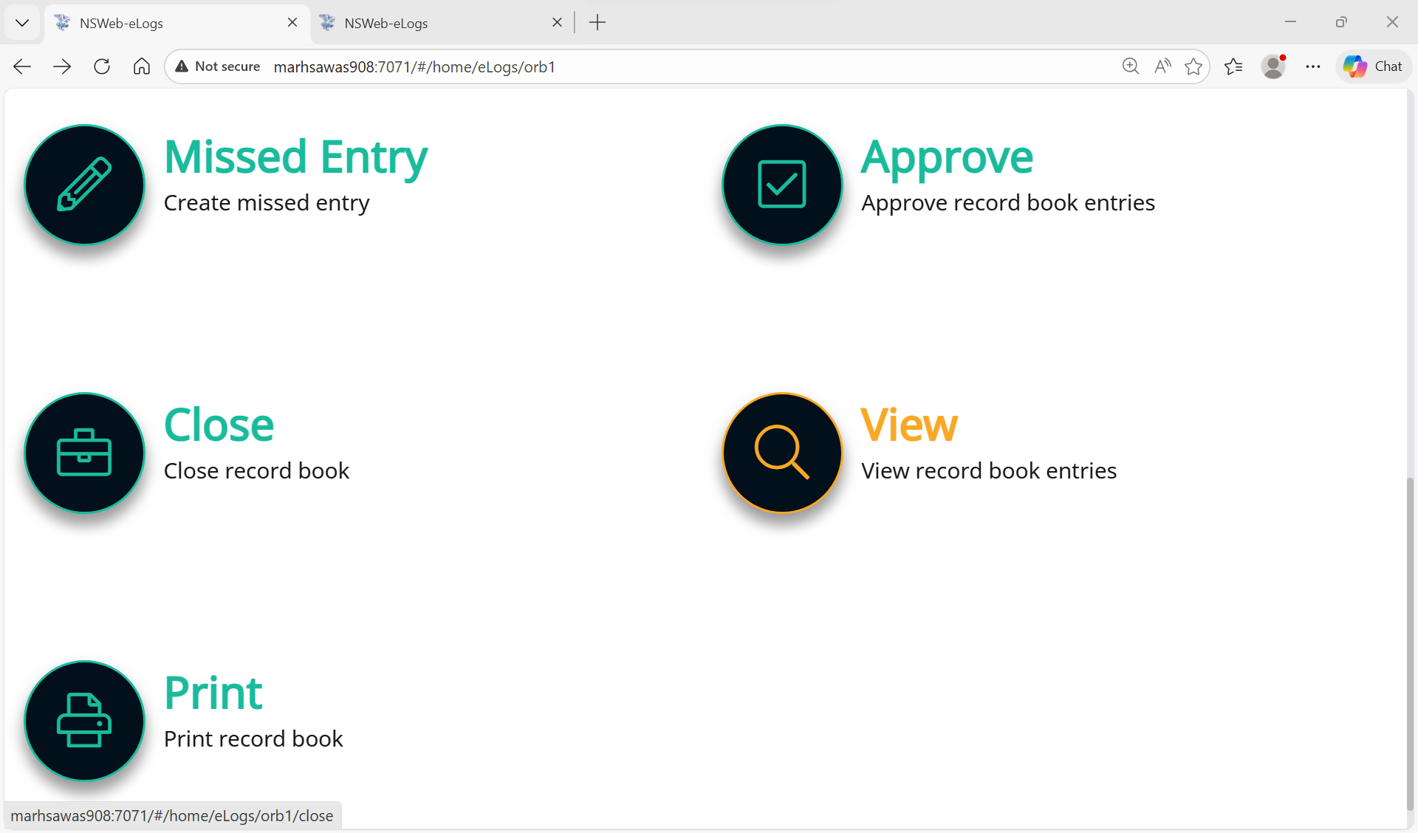

Click on the create + button to record your daily entries.
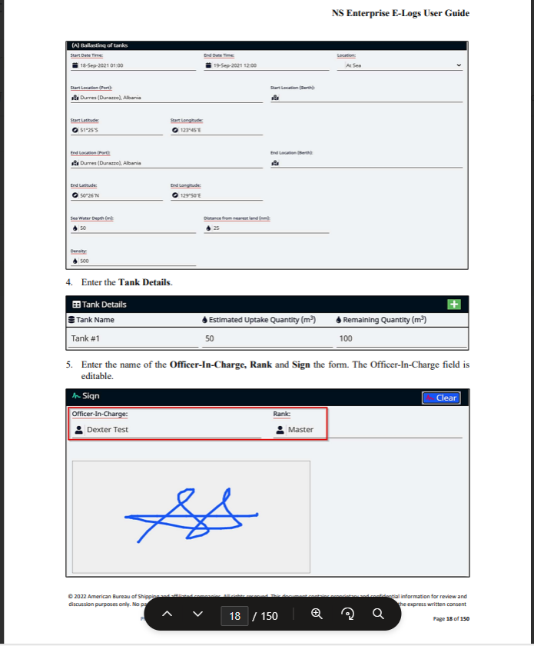
- Clicking on the create (+) button will take you here to this page, the Oil record book template: Entries underlined in red are mandatory and must be completed for submission of the E Log record..

